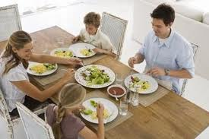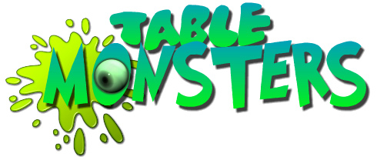
The Manners Matter“Eatiquette Workshop”
For Classy Teens
At the AUC Alumni Lounge
Eat, Drink, and Be Wary!

22nd Feb, 2013
For Ages 13-17
We provide Hands-on Practice over a meal
On Feb 23rd, 2013 (12:00 noon)
Book your Teen’s Place Now!

Workshop fees 200 EGP including meal, 2nd teen gets 50% discount
For Booking, please contact Ms Manar Ayoub, email manara@aucegypt.edu, or Ms Sara Abelrazik, email arazik@aucegypt.edu, Tel: 02 26152382/88
This workshop is provided by  an affiliate of 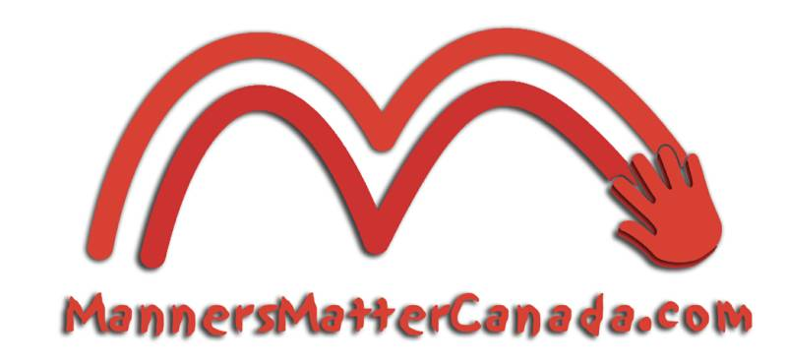
It’s not about being sassy, it’s about being classy and becoming the most popularly invited teen to all events and dining outs
Teens Can Be Cool and Know All About:

Dining Out
deciding what to order, going Dutch, sharing food, and tipping tips
Captain of the Ship
know about navigating the buffet, walking the plank, swimming against the tide, eating what you catch, putting the little ones back, tackling bait, and buried treasures
Cracking the Code
of table place setting, using silverware, and how to eat difficult food
A Fork in the Road
which way to go when facing different table situations: food you don’t like, seconds, eating with your fingers, sopping up sauce, dunking, ejecting inedibles, eating out of containers

